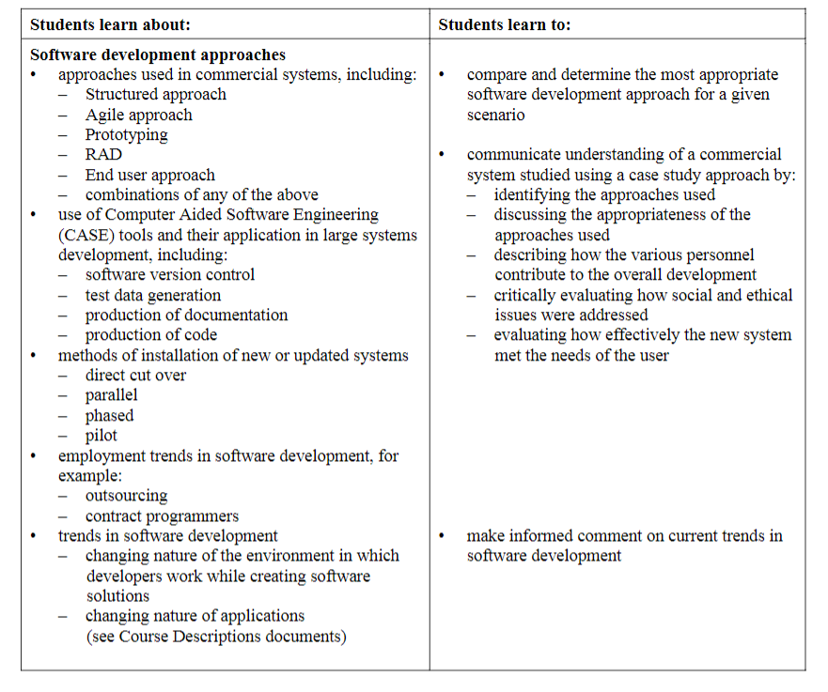

Aiming to base my educational website on the 5 development approaches at the top of the image